|  |
| --- |
|  |
| **Automated Gardening System** |
|  |

**Automated Gardening System**



**Group Members:**

|  |  |  |
| --- | --- | --- |
| Name | Student ID | Department |
| Md. Mehfil Rashid Khan | **13101029** | **CSE** |
| Wasif Shafaet Chowdhury | **12201085** | **CSE** |
| Rishad Mubtasim Jaber | **13121156** | **EEE** |
| Md. Imran Kayesh Mazumder | **13121113** | **EEE** |

**Table of Content**

**Page Number**

1. **Introduction .................................................. 1**
2. **Motivation .................................................. 1**
3. **Equipment .................................................. 2**
4. **Set up .................................................. 2**

**4.1) Fig1: Block Diagram of Automated Gardening System ...... 3**

1. **Working procedure ................................................. 3**
   1. **Fig 2 Working Procedure Flow Chart ........................ 4**
   2. **Fig 3 Full System Flow Chart ................................... 5**
2. **Experimental Result .................................................. 6**
3. **Conclusion .................................................. 6**
4. **Acknowledgement .................................................. 6**
5. **References .................................................. 6**

1) **Introduction:**

In this modern era, where a persons live is getting busier and busier; the hobby of gardening or tree plantation has become a challenging issue. In addition to that the management of resources, especially water resource, has become a matter that should be taken care off immediately. Moreover there are some people who have the time and the resources for gardening but because of the lack of proper knowledge of gardening they are not being able to do so. In some cases because of the lack of proper space in houses some people are finding it difficult to do gardening. In this project we have tried to solve these issues and encourage people to do gardening and increase reforestation. Furthermore our system ensures the best use of water resource and takes good care of plants with minimum human interaction.

In this report an automated gardening system has been proposed, that is portable. Therefore it can be moved to any suitable position. Since the process is fully automated therefore it saves time of people who lead a busy life. On the other hand as the care of the plants is taken in an automated manner therefore this system requires less knowledge in the field of botany or gardening which ensures that anyone can grow plants without any other helping hand and can enjoy the beauty of their own garden. There are some other works have done which are related to our system. An automated irrigation system has been proposed in which the author has emphasized more on the savings of water [1]. Another work that is relevant to our project is “Garduino” it means Gardening with Arduino. Though both of the projects are somewhat related to our system but the process of providing fertilizer to the plants is not automated or the systems are not portable, in our project we have ensured the automatic process of providing fertilizer.

**2) Motivation:**

The main motivation behind this project is that most people face some common problems while pursuing their hobby of gardening. They are,

* Lack of time to sufficiently take care of plants
* Management of resources
* Lack of knowledge on taking care of plants
* Space in their homes

This project will solve these problems and relieve the dilemmas faced by prospective gardeners. This project is created using simple circuits and everyday products making it cost effective and cheap for the masses

1

**3) Equipment:**

1. Clear plastic box
2. 12v Battery
3. Fertilizer Chamber
4. Water Chamber
5. Mixing Motor
6. Wires
7. 2 Water pumps
8. 2 Water level sensor
9. Moisture sensor
10. Buzzers
11. Sealant
12. Plants
13. Soil, fertilizer and water
14. Pipes

**4) Set up:**

* Two Plastic Chambers are connected in the sides of a Rectangle Box.
* One of the chambers, the Water chamber, is connected to a pump using pipes. Another pipe, with one of its end connected to the pump, is inserted through the east side of the box and out the west side. The end outside of the west side is sealed shut. The pipe section inside the box is above soil level and has small hole outlets
* The other chamber, the Fertilizer chamber, has a small motor, a mixing fan attached at its head, at the bottom of the chamber. It is connect to another pump using pipes. Another pipe, with one of its end connected to the pump, is inserted through the north side of the box and out the south side. The end outside of the south side is sealed shut. The pipe section inside the box is above both soil level and water pipeline and has small hole outlets.
* Using wires, both the water pumps and the motor is connected to the output pin of an arduino through relay switches.
* A 12V dc Battery is also connect to both pumps and motor through relay switches
* A moisture sensor is connect to the input pin and it is embedded halfway into the soil
* 2 water level sensors are connected to the input pins of arduino and they are embedded in the side of the water and fertilizer chamber.

2

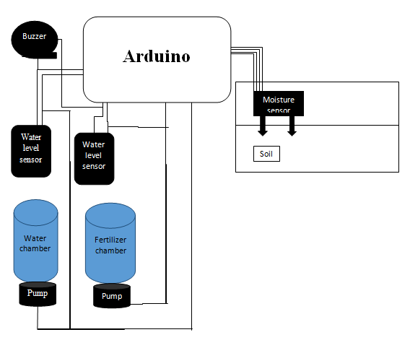

**4.1) Fig 1: Block Diagram of Automated Gardening System**

**5) Working procedure:**

* The concept the device is that plants require regular intakes of water and fertilizer.
* A timed injection of both water and fertilizer given at regular interval is necessary for their growth.
* A digital system operated by arduino is used to deliver this
* Water pump draw water from the water chamber and inject it to plants via pipes
* A motor at the bottom of the fertilizer chamber mixes the fertilizer with water to make a healthy solution which is inject using another pump
* The timing and the interval of the injection is controlled by sensors via arduino.
* The moisture sensor ensures that the moisture level inside the device is optimum. If it decreases beyond the optimum level it activates the water pump
* Fertilizer injection is timed for regular intervals i.e. once per day

3

* Water level sensors detect the decreasing level of resources and alert when the resources are depleted and in need of refill
* As all the equipments and the codes are already done and working properly therefore it does not require any expertise
* All of the processes are being done automatically and being controlled by an arduino so it requires minimum human interaction and it is the main concept behind our system.

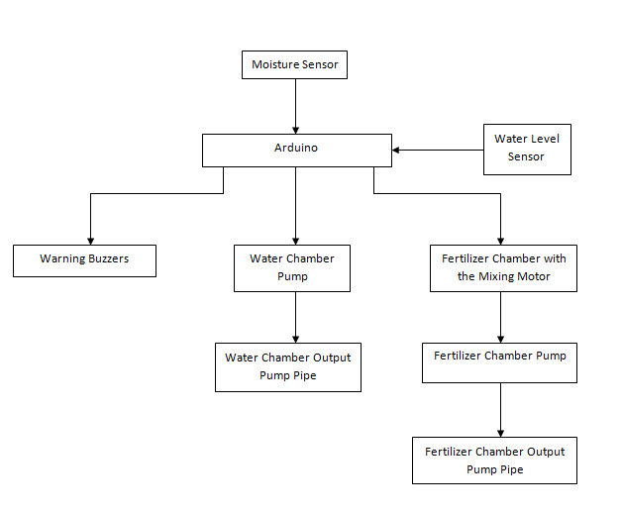

**5.1) Fig 2: Working procedure of Automated Gardening System: step by step**

4

Fertilizer Chamber Mixing Motor Activated For 2 min

Yes

No

Is the Soil Dry?

No

Yes

Yes

Yes

Activate Buzzer

Water Chamber Pump Activated

Mixer Level below the Stated Limit

Timer Reached one week

Activate Buzzer

Water Level below the stated limit

Water Level Sensor

Arduino

Moisture Sensor

Fertilizer Chamber Pump Activated

Enough Water

No

Yes

If time ==1 min

No

Turn off Pump

Turn On LED

Yes

Turn off Mixing Motor

Turn off Pump

Turn on LED

**5.2) Fig 3: Flow chart of full system operating procedure**

5

**6) Experimental Result:**

The system is working properly the water is being provided to the plants when the moisture level goes under a certain level and the fertilizer is supplied to the plants once in a week. But water pump is not being able to pull up the water at a certain level, because of the limitation of power. Therefore the water chamber and the fertilizer chamber have been directly attached to the pumps. As a result flow of water and the mixture of fertilizer were difficult to control. To solve this problem we have used extra piping which does not allow the mixture and water to flow unless the pump is switched on. Another problem that we have faced was regarding the fan that is attached with the motor in the mixing chamber. A fan that can be directly and strongly attached with the motor of the mixing chamber was difficult to find. As a result the mixing fan had to be made and was attached at the top of the mixing motor using glue.

**7)** **Conclusion:**

Through this device we hope to contribute to the ecosystem by providing a cheap and efficient means of growing plants in urban areas. There are not enough trees and plants especially in the city areas and as a result global warming is an ever growing threat. Our hope is that we can at least contribute to our planet by spreading greenery everywhere while helping people follow their gardening hobby along the way.

**8) Acknowledgement:**

Deforestation, pollution and global warming have become a global issue in recent years and many initiatives have been taken under consideration to control or to solve these problems. Many researches and conferences have been conducted to provide a sustainable and efficient solution of them. The automation process of gardening and irrigation can be a helping hand to face these challenges. Recently some advancement has been done in case of the implementation of the automation process of spreading greenery. The Automated Irrigation System or Garduino can be a good example of the above mentioned automated gardening system. The goal of this project is to add an extra helping hand in the process of automated gardening system and encourage people to plant more and more trees.

**9) References:**

1. Automated Irrigation System, M. F. Leroux and G. S. V. Raghavan, “*Design of an Automated Irrigation System*”, McGill University

6